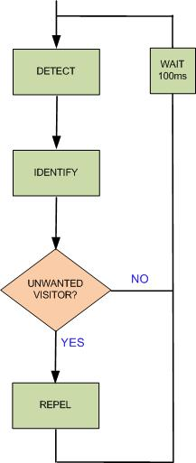
CIRCUIT CONSTRUCTION
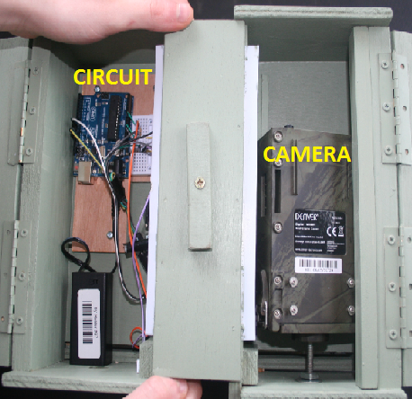
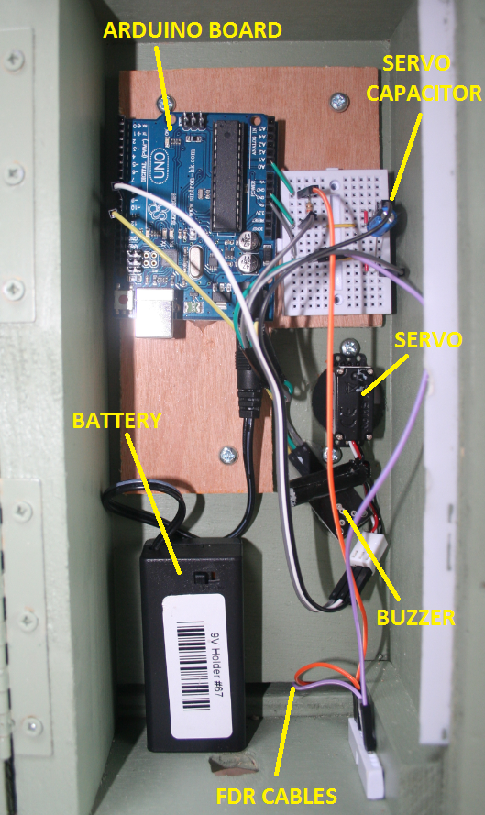

Software Flowchart

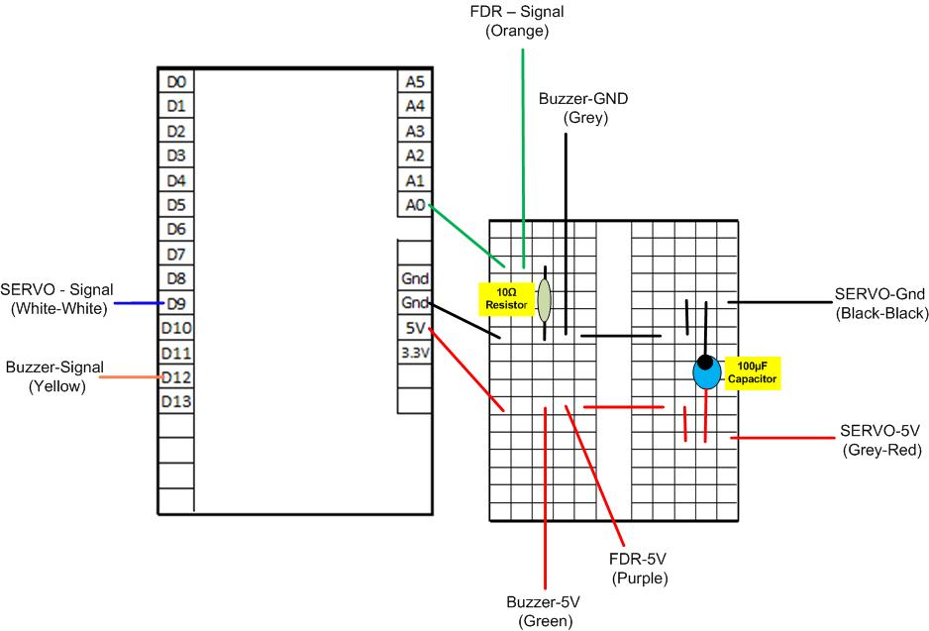

Circuit Wiring
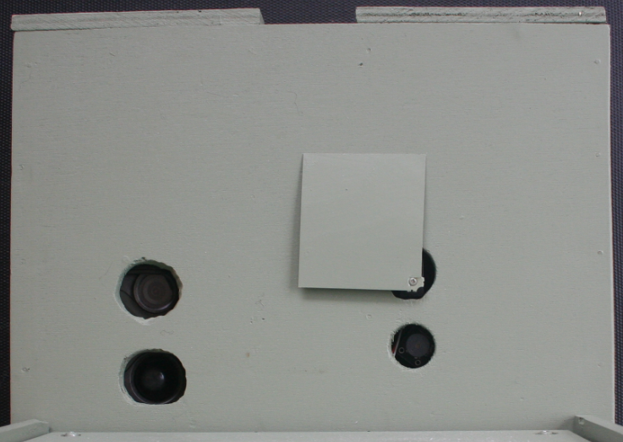

“Birds eye” view from feeding table when the process to repel unwanted visitors is triggered. The servo motor turns 90 degrees clockwise to reveal the predicator. At the same time the buzzer below emits a screeching sound

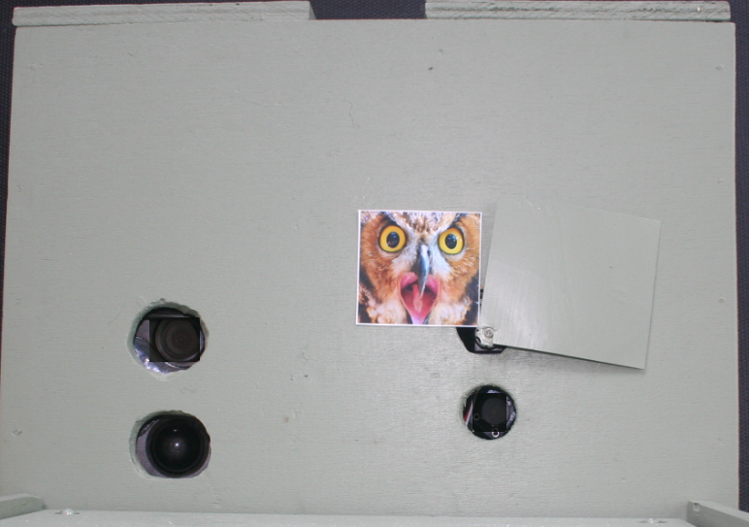
“Birds eye” view from feeding table when no unwanted visitors are present

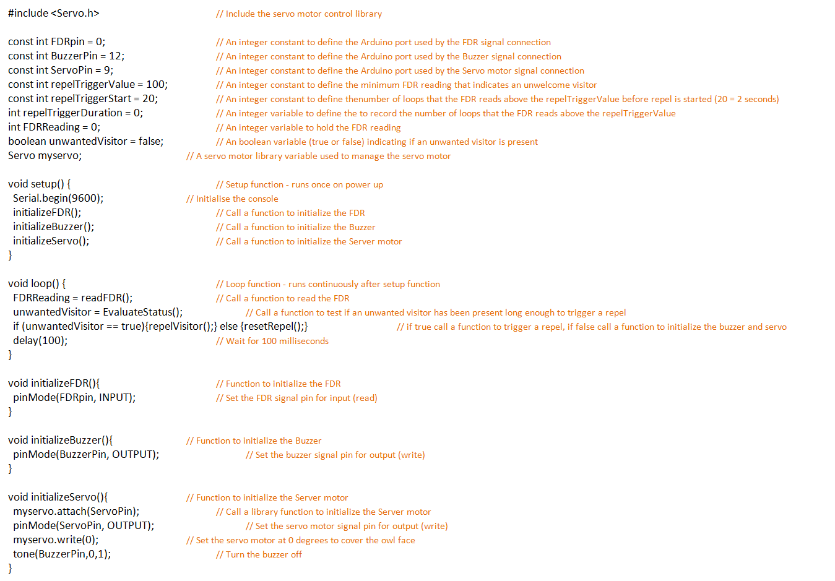
ARDUINO SOFTWARE
